Life Below Water

Introduction to Goal 14 - Life Below Water

Use this guide to introduce Global Goal 14, Life Below Water to your students.
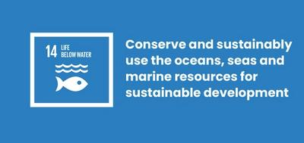
What is Global Goal 14: Life Below Water?
Sustainable Development Goal 14: Life Below Water is one of the 17 Sustainable Development Goals established by the United Nations in 2015. You can find out more about the Goals in our introductory guide. Healthy oceans and seas are essential to our existence. They cover 70 percent of our planet and we rely on them for food, energy and water. Yet, we have done tremendous damage to these precious resources.
Goal 14 includes targets to:
- Reduce marine pollution
- Control illegal fishing, overfishing, and other destructive fishing practices through laws
- Minimize and address the impacts of ocean acidification
- Conserve at least 10% of coastal and marine areas

Активности
Below are some ideas to help bring Goal 14 to life for your students. Активности су индивидуалне или представљају низ активностиву оквиру једне лекције.

Activity 1: Thinking about our oceans

In this activity, students will reflect on what they know about oceans and the threats they face.

Дужина трајања - 10 минута
Watch the video below with your students.
https://www.youtube.com/watch?v=epQHFPvqWHY
After you’ve watched, discuss:
- How do you feel about oceans?
- Did you learn anything new about the problems they are facing?
- Does any of it relate to your own lives?
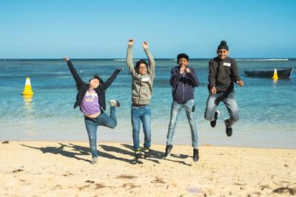

Activity 2: Our impact on oceans

In this activity, students will create a mind map to explore the issues facing our oceans.
Дужина трајања - 15 минута
- In small groups, ask students to list as many problems facing our oceans that they can think of.
- Answers could relate to: Pollution e.g. sewage, chemicals and plastic; Warmer water; Acidity increasing due to carbon emissions; Overfishing; Damage to sea life; Coral bleaching; Ecosystem breakdown.
- Now it’s time to make a mind map - a diagram used to visually organise information.
  - Write down all of the problems onto sticky notes and group together the problems which are linked on a board or large piece of paper.
  - Write down the effects of these problems, to your own community and around the world, on to sticky notes and add them to the mind map. Also think about the causes.
  - Now introduce Global Goal 14: Life Under Water using the definition above. Your mind map should represent the issues related to that Goal. Have you missed any?
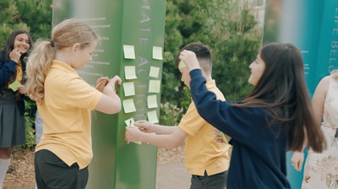

Activity 3: Why oceans matter

In this writing activity students will be encouraged to think about how humans suffer when we damage life below water.
Length - 25 mins

Увод
Students will write a journal from the perspective of someone who is experiencing a problem linked to the sea or ocean. They could pick problems from the list in activity 2 - then think about who would be most affected by this problem?
Here are a few examples:
- A small-scale fisherman in Senegal. His community have relied on sustainable fishing for food and income for years, but they are catching fewer and fewer fish due to industrial-scale fishing in the same area.
- A child who lives near Kamilo Beach, located on the south-eastern tip of Hawaii's Big Island, one of the most plastic-polluted places on Earth
- A marine biologist in Australia who studies coral reefs and runs scuba diving trips for tourists to visit the Great Barrier Reef. In the past 20 years she has seen the entire area become threatened.
- A surfer in Cornwall, UK. Sometimes it is unsafe to surf because sewage is being pumped directly into the sea from land.
Before starting, download the Global Goals grid to identify all the Goals which are affected by this problem. For example, they might rely on the ocean for food - Goal 2: Zero Hunger - or for income - Goal 8: Decent Work and Economic Growth. This will help students think about the wider effects of the issue.

Writing the journal
Now ask the students to spend 10 - 15 minutes writing a journal entry by this person.
- What is the problem they are facing and what is the cause?
- What is the effect on them and their community?
- What was the situation like in the past and what is the situation now?
- How do they feel about it?
- What can they see, smell, hear, touch and taste?
- What are their worries for the future? What about their hopes?
- Are they taking any action to stop the problem? What do they need?

Reflection
When students have finished, ask them to share what they have written and their reflections as a group.

