Reduced Inequalities

Introduction to Goal 10 - Reduced Inequalities

Use this guide to introduce Global Goal 10, Reduced Inequalities to your students.
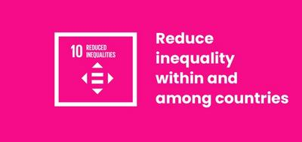

What is Global Goal 10?
Sustainable Development Goal 10: Reduced Inequality is one of the 17 Sustainable Development Goals established by the United Nations in 2015. You can find out more about the Goals in our introductory guide.
The full title of Goal 10 is: "Reduce inequality within and among countries". It has ten targets relating to inequality in all forms - from income and economic inequality and lack of representation in politics to discrimination based on gender, disability, race, and migration.
The UN describes Global Goal 10 as follows:
Too much of the world’s wealth and power is held by a very small group of people. This often leads to financial and social discrimination. In order for nations to flourish, equality and prosperity must be available to everyone - regardless of gender, race, religious beliefs or economic status.

Активности
Below are some ideas to help bring Goal 10 to life for your students. Активности су индивидуалне или представљају низ активностиву оквиру једне лекције.

Teacher’s guide to teaching Goal 10: Reduced Inequalities
Before teaching these lessons you should check whether any of your students are affected by any of these inequalities. These are sensitive topics and in order to discuss them openly and happily you need to make sure the classroom is a ‘safe’ environment for all of your students.
These activities are an introduction to some of the many types of inequality that exist in the world. It can be easy to fall back on stereotypes when describing these situations. Try to actively deconstruct any stereotypes as this will “steer” students away from falling back on them. Remind them that there is a lot of complexity to why inequality exists and what it is like for people to live with.
As you teach this lesson, and especially as you cover the true and false learning activity, make sure you explain that these inequalities exist because systems are discriminatory against the poor, minority groups, people with disabilities, women, the elderly and other groups in societies.
Ensure that students do not attribute inequality to inferiority or stereotypes.
Make sure that when you describe or discuss these discriminatory systems you make it clear that there are many positive facts and achievements amongst people who are part of historically marginalised groups.
Follow and consult your school's equality policy.
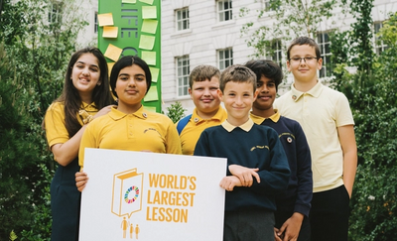

Activity 1: Introducing Inequality

In this activity, students will be introduced to the concept of inequality.
Length - 10 mins
- Distribute a number of sweets / biscuits / stickers / counters unevenly. Some students should have a lot, some students have none. Keep the majority for yourself.
- Ask students “Is this fair?” Encourage students to discuss this as a class. Ask the students to discuss how they feel about the distribution they have.
- Explain to the students that you have the most because you are the oldest. Is that fair? What about if you gave the tallest children more than the shortest? Or all the boys had to give theirs to the girls?
- Use this example of inequalities to introduce the idea of social inequality. This definition might be useful: “a situation in which people are not equal because some groups have more opportunities, power, money, etc than others” (source: MacMillan dictionary)
Goal 10 is summarised in the following video:
https://www.youtube.com/watch?v=6DlQq2xLw_0

Activity 2: The Impact Of Inequality

In this activity, students will think about inequality and the impact it has on individuals, their families, right through to the whole world.
Length - 30-40 mins
- Together, make a list of all of the different forms of inequality that students can think of. Then, in small groups, students should chose one form of inequality to focus on.
- Students should write down all of the impacts of this inequality that they can think of to create an impact chain. Guide students to think about the impact in this order:
  - Individuals - what is the impact of the inequality on the individual?
  - Their families - how does it then affect their family?
  - Local community - what impact with this have on their local community?
  - Whole country - how will this impact the whole country?
  - The world - finally, what impact will this inequality have on the world?
- As an extension, they could also think about economic, social, political and environmental effects.
- When they are finished, find ways for students to share their work and reflect on what they’ve learned.

